**QUALTRICS TUTORIAL**

**CREATING A SURVEY IN QUALTRICS**

1. Log into Qualtrics using your WVU credentials: <https://wvu.qualtrics.com>
2. On the landing page, select “Blank Survey Project.”

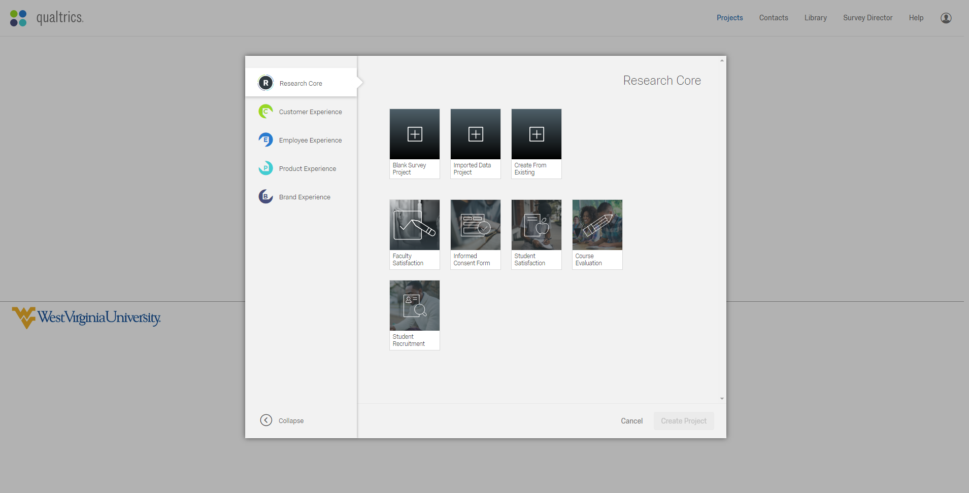

1. Give your project a name and create the project.

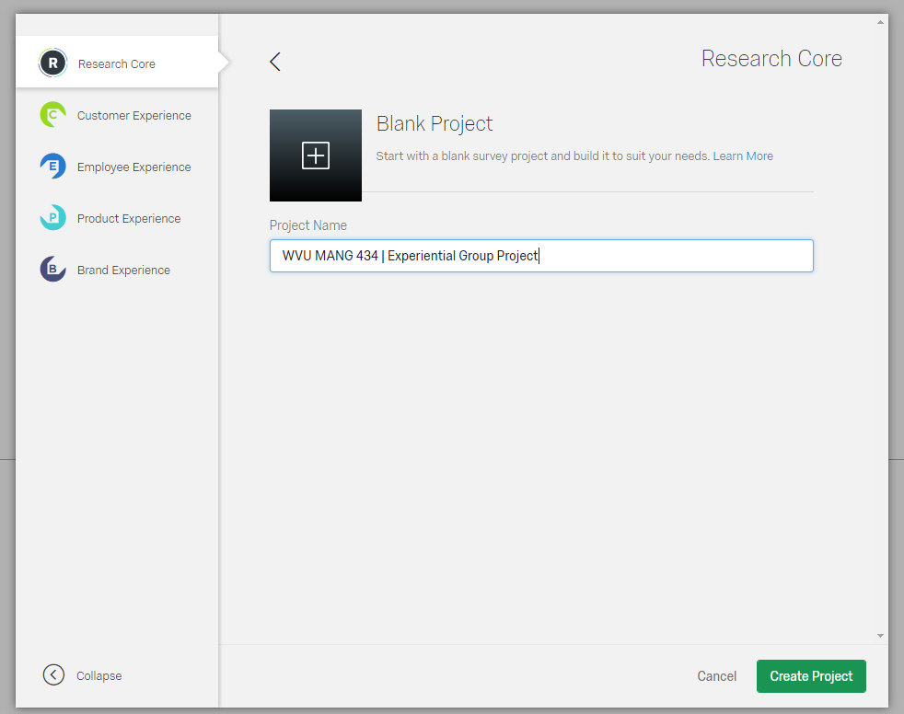

**SHARING YOUR SURVEY WITH INDIVIDUALS IN YOUR GROUP**

1. How to share your survey with other group members
   1. On the project homepage, click on “Collaborate,” which is located in one of the upper toolbars

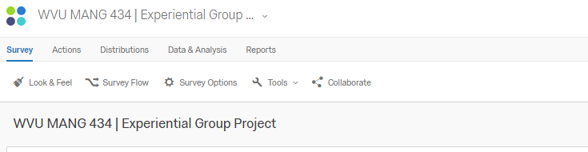

* 1. Enter your teammates’ WVU username into the search box. Their name should appear as long as they have already logged into WVU Qualtrics.
  2. Click on “Add” after selecting the individual

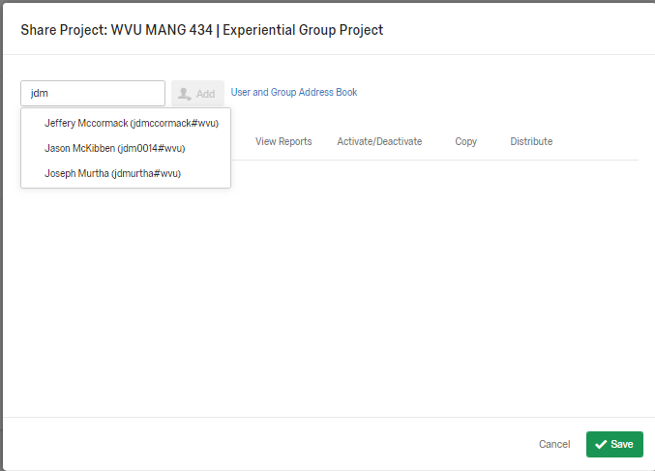

* 1. Select each box to give the individual (you teammate) full authorship access to the survey

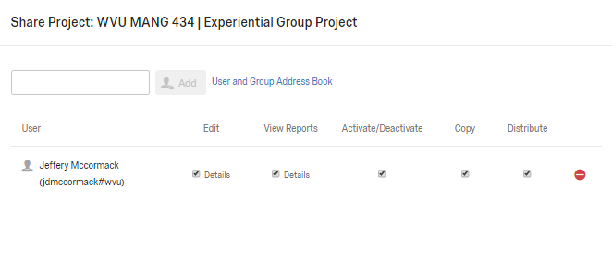

**CREATING BLOCKS AND ITEMS**

1. Create a “block” of items (i.e., survey questions).

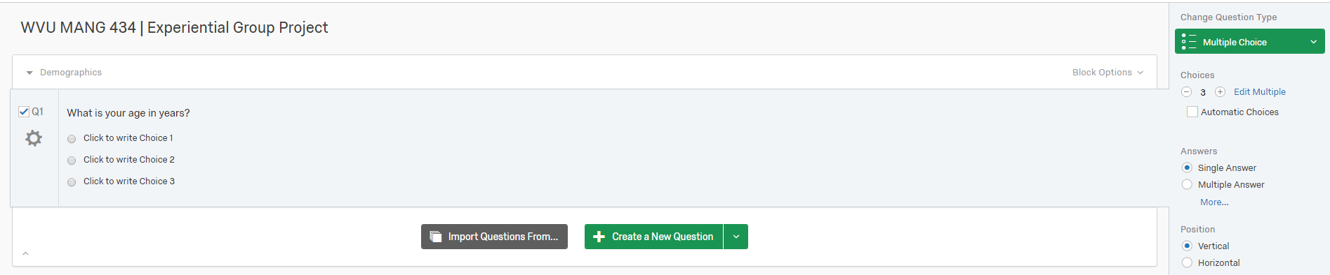

1. Create question(s) within the question block.
   1. For this example, the first demographic-related question is: What is your age?
   2. Of course, this should not be associated with a multiple choice response option.
   3. To change the response option, click on the green box (Multiple Choice), which is located on the right-hand side of the screen.



* 1. After clicking on the green box, a drop-down menu will appear that shows the different response options.
  2. Select “Text Entry” as this option will allow respondents to enter their exact age

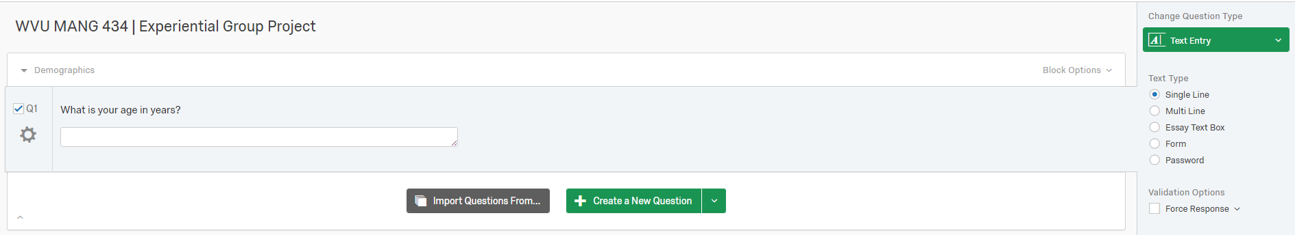

1. To create another question related to the first “block,” click on “Create a New Question.” This is the green box that is located at the bottom center of the screen.



1. For this example, the second demographic-related question is: What is your gender?
   1. Qualtrics will auto-populate “Male” and “Female” as response options to this question
   2. I suggest adding “Other” as a response option to this question. This can be done clicking on “+” in the panel on the right-hand side of the screen.

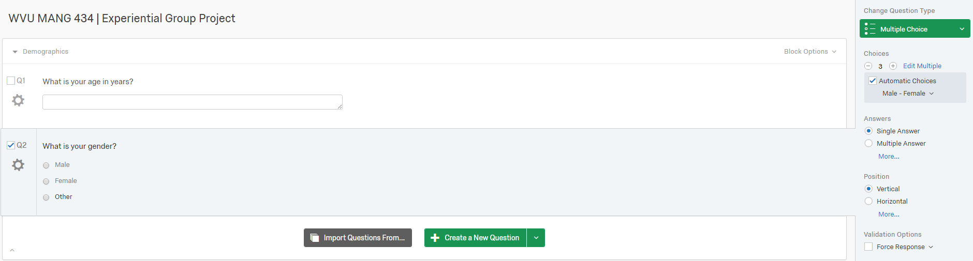

1. For this example, the third demographic-related question is: What is your race/ethnicity?
   1. Additional response options can be added by clicking on the “+” in the panel on the right-hand side of the screen (see 7b above) or by simply clicking the “Enter” button on your keyboard.

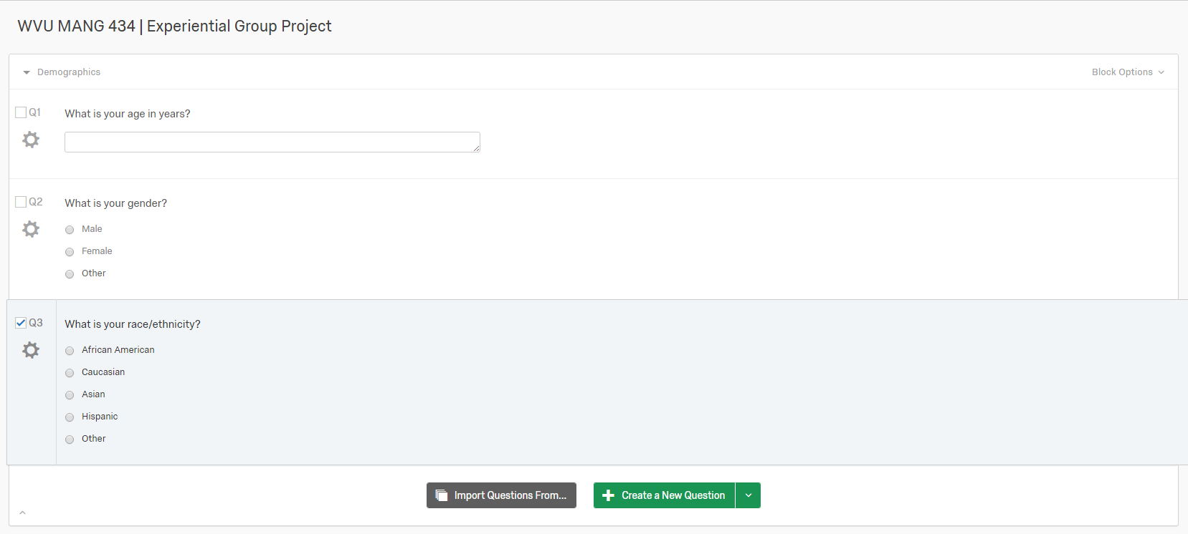

1. To add a new question “block,” click on “Add Block,” which is located below the green box that is located at the bottom center of the screen.

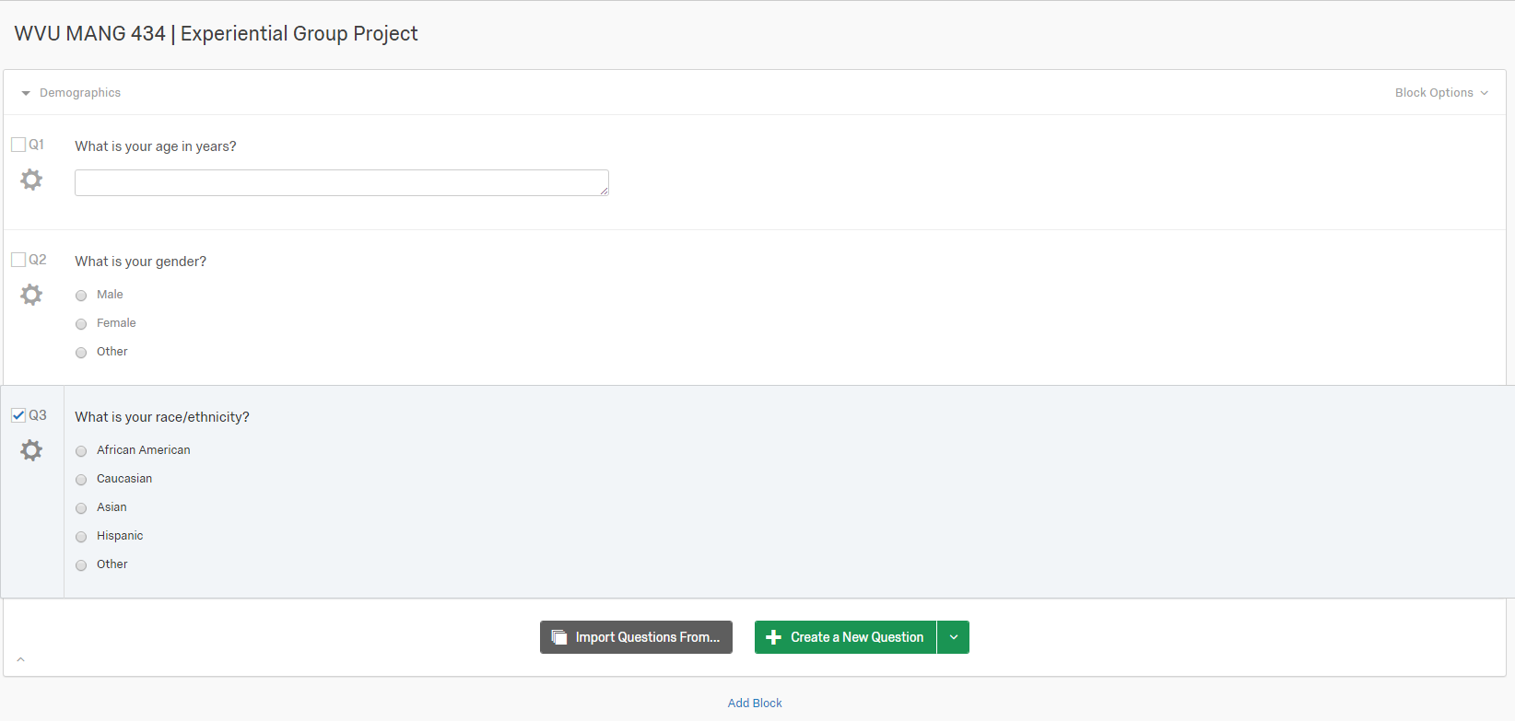

1. A new block will appear below the existing one(s). Repeat the aforementioned steps to create and tailor new survey questions and “blocks.”

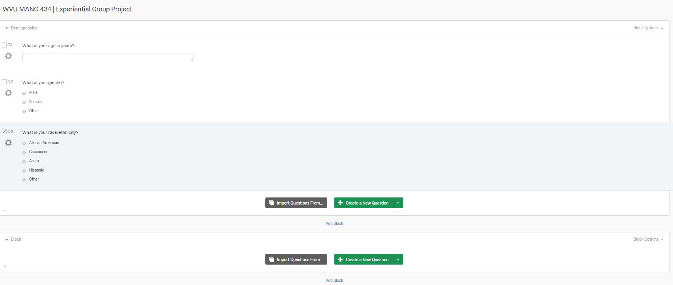

**FINALIZING YOUR SUVEY**

1. When you are finished creating blocks and questions, you should preview the survey. Inspect the survey for errors.

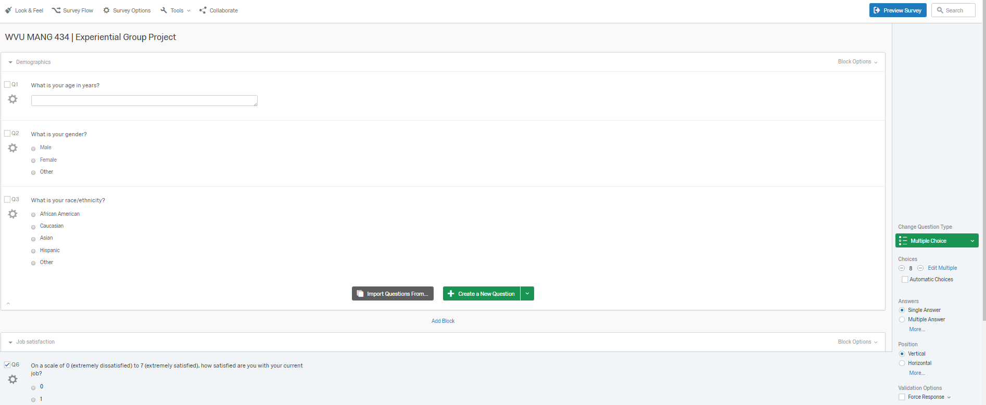

**DISTRIBUTING YOUR SURVEY**

1. After previewing the survey and correcting any errors, you are ready to “go live.”
   1. Click on “Distributions,” which is located in one of the upper toolbars

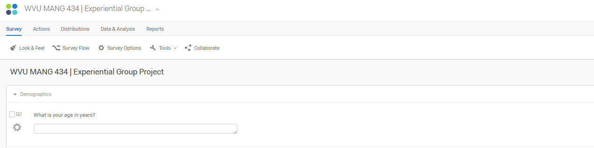

1. Surveys can be distributed in a number of ways. However, I suggest creating a single reusable link, which will allow you to invite individuals to respond to the survey via email, social media, etc.

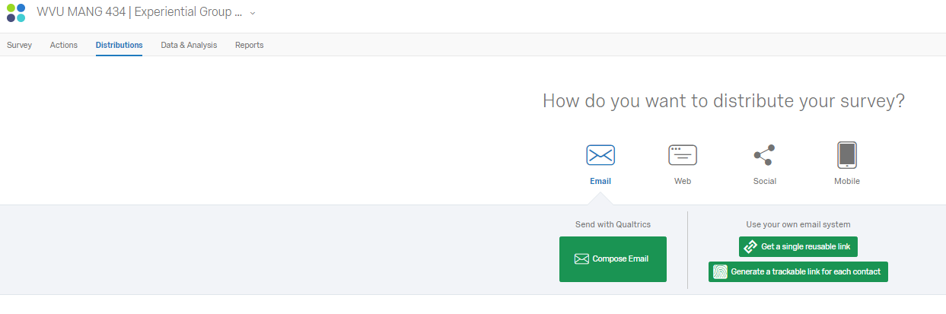

1. Qualtrics will provide you with a unique link to the survey. However, you can also customize this link (if you want to).

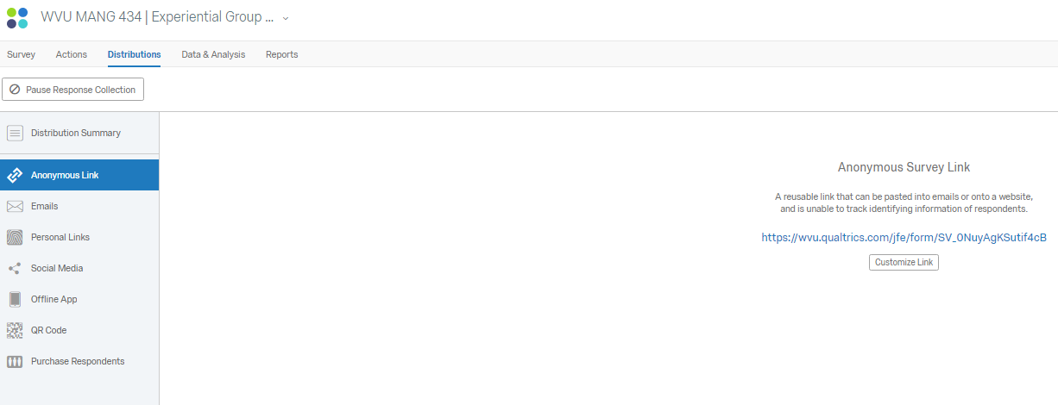

**ACCESSING THE DATA COLLECTED BY YOUR SURVEY**

1. At the end of the data collection phase, you will need to export the data collected in Qualtrics.
   1. To do this, click on the “Data & Analysis” button, which is located in one of the upper toolbars

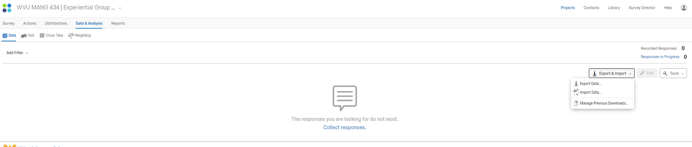

1. We will need to export the data in a comma separated values (.csv) file.
   1. To do this, click on the “↓Export & Import” button, which is located on the right-hand side of this screen.
   2. From the drop-down menu options, select “Export Data.”



1. Click on “Download” and save the exported data file to the appropriate

